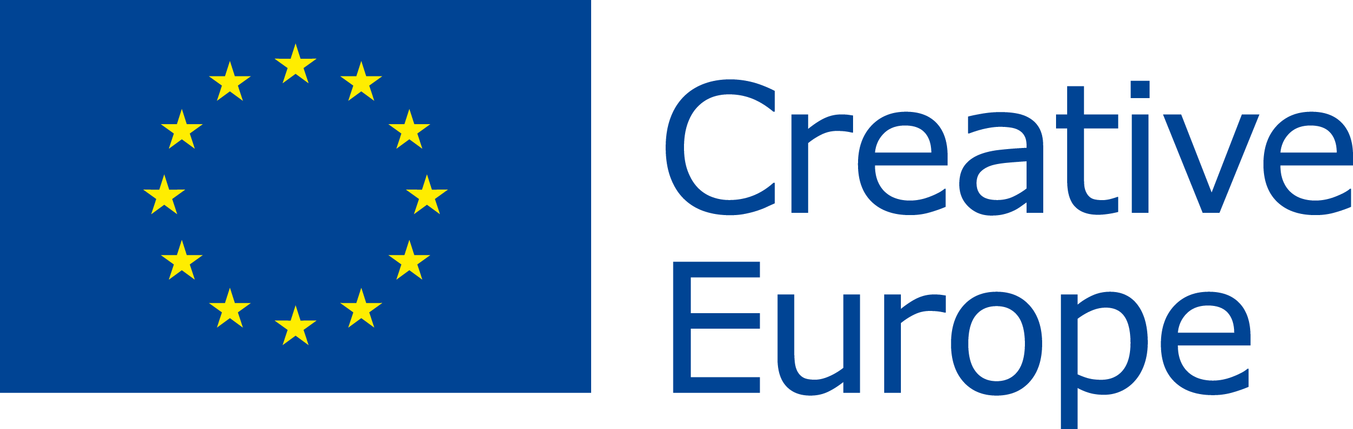 PRESS RELEASE  Embargoed 5 April 2017, 12:00 CET |  |  | 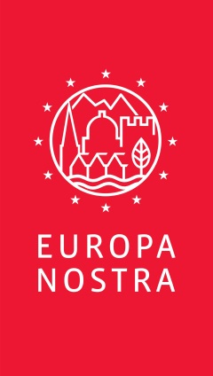
Paavo Nurmi Legacy project wins an
EU Prize for Cultural Heritage / Europa Nostra Award 2017

Brussels / The Hague, 5 April 2017 - The European Commission and Europa Nostra revealed today the winners of the 2017 European Union Prize for Cultural Heritage / Europa Nostra Awards, Europe’s top honour in the heritage field. The 29 laureates from 18 countries are being recognised for their notable achievements in conservation, research, dedicated service, and education, training and awareness-raising. Paavo Nurmi Legacy project, Turku, is among this year’s winners. Independent expert juries examined a total of 202 applications, submitted by organisations and individuals from 39 countries across Europe, and chose the laureates.

Citizens from around the world can now vote online for the Public Choice Award and rally support for the winning project(s) from their own or another European country. Voters have the chance to win a trip for two to Finland and be a special guest at the Awards Ceremony that will be held in the historic city of Turku on 15 May. During the ceremony, the seven Grand Prix laureates, each of whom will receive €10,000, and the Public Choice Award winner, chosen from among this year’s winning projects, will be announced.

"I congratulate all the winners. Their achievements demonstrate once again how engaged many Europeans are in protecting and safeguarding their cultural heritage. Their projects highlight the significant role of cultural heritage in our lives and our society. Especially today, with Europe facing many big societal challenges, culture is vital in helping us to raise awareness of our common history and values and to foster tolerance, mutual understanding and social inclusion. The European Year of Cultural Heritage in 2018 will be an ideal opportunity to focus on what binds us together as Europeans - our common history, culture and heritage. The European Commission will continue to support this prize and other heritage projects through our Creative Europe programme,” said Tibor Navracsics, European Commissioner for Education, Culture, Youth and Sport.

“I warmly congratulate this year’s winners and pay tribute to all those who made these exceptional achievements possible, thanks to their formidable talent, passionate commitment and great generosity. They are now among a select group of some 450 remarkable accomplishments awarded by Europa Nostra and the European Commission in the past 15 years. All our winners demonstrate that heritage is a key tool for sustainable economic development, social cohesion and a more inclusive Europe. EU leaders should seize the historic opportunity of the European Year of Cultural Heritage in 2018 to recognise the multiple benefits of heritage and its fundamental value in bringing countries, communities and cultures together in Europe and beyond,” stated Plácido Domingo, the renowned opera singer and President of Europa Nostra.

The winners of the EU Prize for Cultural Heritage / Europa Nostra Awards 2017 will be celebrated during a high-profile event co-hosted by EU Commissioner Navracsics and Maestro Plácido Domingo commencing in the late afternoon on 15 May at St. Michael’s Church in Turku. The European Heritage Awards Ceremony will assemble some 1,200 people, including heritage professionals, volunteers and supporters from all over Europe as well as top-level representatives from EU institutions, the host country and other Member States.

The winners will also present their exemplary heritage accomplishments during the Excellence Fair on 14 May at the Sigyn Hall of the Turku Music Conservatory, and participate in various events at the European Heritage Congress in Turku (11-15 May). Organised by Europa Nostra, the Congress will provide an inspiring platform for networking and debating the latest European developments related to heritage with a special focus on the European Year of Cultural Heritage 2018.

Applications for the 2018 edition of the Awards can be submitted from 15 May to 1 October 2017 through the dedicated website.

PRESS CONTACTS  For Europa Nostra  Joana Pinheiro, jp@europanostra.org, +31 70 302 40 55  Elena Bianchi, eb@europanostra.org, +31 70 302 40 58  For the European Commission  Nathalie Vandystadt  nathalie.vandystadt@ec.europa.eu, +32 2 2967083  Joseph Waldstein  joseph.waldstein@ec.europa.eu, +32 2 2956184  Europa Nostra Finland  Anna-Maija Halme  anna-maija.halme@europanostra.fi, +358 40 536 8188  Paavo Nurmi Legacy project  Mrs. Veera Sahlberg,  veera.sahlberg@paavonurmigames.fi, add mobile number here | TO FIND OUT MORE  About each winning project:  information and jury’s comments,  high-resolution photos and videos  Twitter: @europanostra  Creative Europe website  Twitter: @europe_creative  Commissioner Navracsics website  www.europanostra.fi  www.paavonurmi.fi

2017 Award Winners
(listed alphabetically by country)

Category Conservation
▪ St. Martin’s Chapel in Stari Brod, near Sisak, CROATIA
▪ Baroque Complex and Gardens in Kuks, Hradec Králové region, CZECH REPUBLIC
▪ Ancient city of Karthaia, Island of Kea, GREECE
▪ Bastion of the Grand Master's Palace in Rhodes, GREECE
▪ White Pyramid in Rome, ITALY
▪ The King’s Road across Filefjell, NORWAY
▪ The Clérigos’ Church and Tower in Porto, PORTUGAL
▪ Cultural Palace in Blaj, Transylvania region, ROMANIA
▪ Cap Enderrocat Fortress, Mallorca, SPAIN
▪ Roof for the ruins of the Monastery of San Juan in Burgos, SPAIN
▪ Cromford Mills: Building 17, Derbyshire, UNITED KINGDOM

Category Research
▪ Rode Altarpiece Research and Conservation Project, Tallinn, ESTONIA
▪ ‘Carnival King of Europe’, San Michele all’Adige, ITALY
▪ Museum Piranesi’, Milan, ITALY
▪ Bosch Research and Conservation Project, ‘s-Hertogenbosch, THE NETHERLANDS

Category Dedicated Service
▪ Mr. Ferdinand Meder, Zagreb, CROATIA
▪ Mr. Jim Callery, County Roscommon, IRELAND
▪ The Norwegian Lighthouse Society, NORWAY
▪ Mr. Zoltán Kallós, Transylvania region, ROMANIA

Category Education, Training and Awareness-Raising
▪ Erfgoedplus: Online heritage platform, Hasselt, BELGIUM
▪ Centre of Visual Arts and Research, Nicosia, CYPRUS
▪ Educational programme for Czech cultural heritage, Telc, Vysočina region, CZECH REPUBLIC
▪ Paavo Nurmi Legacy project, Turku, FINLAND
▪ Heritage Crafts Initiative for Georgia, Tbilisi, GEORGIA
▪ Cultural Heritage and Barrier-free Accessibility project, Berlin, GERMANY
▪ ilCartastorie: Storytelling in the archives, Naples, ITALY
▪ Jewish Cultural Heritage: Educational programme, Warsaw, POLAND
▪ Advanced Master in Structural Analysis of Monuments and Historical Constructions, European programme coordinated in Guimarães, PORTUGAL
▪ SAMPHIRE: Maritime heritage project in western Scotland, UNITED KINGDOM

A Europa Nostra Award is also presented to remarkable heritage projects from two European countries not taking part in the EU Creative Europe programme.

Category Conservation: Kılıç Ali Paşa Hamam in Istanbul, TURKEY
Category Research: Philippe Stern’s Collection of Timekeepers, Geneva, SWITZERLAND

Paavo Nurmi Legacy project, Turku, FINLAND
The long-distance runner Paavo Nurmi, known internationally as ‘The Flying Finn’, has captivated the world since his astonishing triumph in winning 12 Olympic medals in the 1920s. His extraordinary achievement guarantees his legacy as one of the most successful Olympians of all time. His legacy forms an important part of Finland’s cultural heritage and national identity. Having gained independence from Russia in 1917, Paavo Nurmi’s success and world renown is unmistakably linked to those first years of Finland’s independence and its burgeoning identity in a global context.
To honour this achievement, the Paavo Nurmi Legacy was established to commemorate this victory and to link this sporting history to the nation’s cultural heritage. Through an array of events, such as the Paavo Nurmi Games and the Paavo Nurmi Festival, the Paavo
Nurmi Legacy project has succeeded in affirming this heritage in the public consciousness. The Paavo Nurmi School Tour aims to raise awareness of this heritage by visiting schools and providing engaging lessons in sports and heritage. To date, over 10,000 primary school children have been reached in 100 schools across Finland. The jury was impressed by how “the project has a notable impact in the community, especially within schools and amongst young people, whom they inspire through their activities”.
With a relatively limited budget, financed by several stakeholders with both public and private funds, the impact that the Paavo Nurmi Legacy has managed to make is remarkable and their commitment to establishing their international influence is commendable.
Thejury noted that “the programme’s holistic communication approach is wide-reaching with a website available in no less than nine languages. This aids them in bringing the Finnish legacy to a European and global heritage context. The digitisation of the literature and other materials has also helped to preserve Paavo Nurmi’s legacy and allows easy access to these important materials”.
“Iti s increasingly important to recognise the link between sports and heritage as the Paavo Nurmi Legacy project has succeeded in doing”, emphasised the jury.

